SOP: Assistant Team Leader
Module | Assistant Team Leader
Who uses it | Assistant Team Leader
Version | 1.0
Issued | 21 Oct 2026
Screenshots are taken from the HRMS test copy. Names, dates and numbers are examples only.

1. Purpose
Assistant Team Leaders follow their own team's work and keep the team roster. Everything except the roster is view only.

2. What you can use
Screen | What you can do
Analytics | View your team's overview, billable report and KRA. Overview cards are explained in SOP - Manager - Reports, section 2.
Tracker Report | View your team's tracker entries. The Task EOD Report tab joins all agents' files for a task and day into one Excel (see SOP - Manager - Reports, section 9).
Manage > Roster Management | Edit your team's days and leave, and submit them for approval (see SOP - Manager - Roster).
Manage > SOPs / SOPs | Read the SOP library.

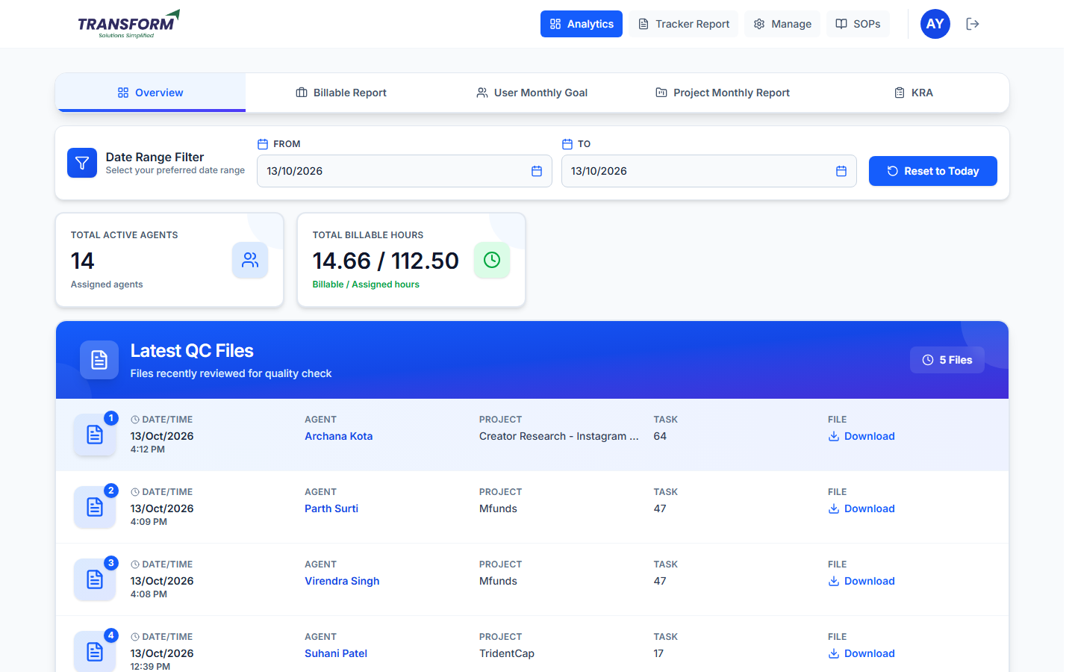
Figure 1: Overview
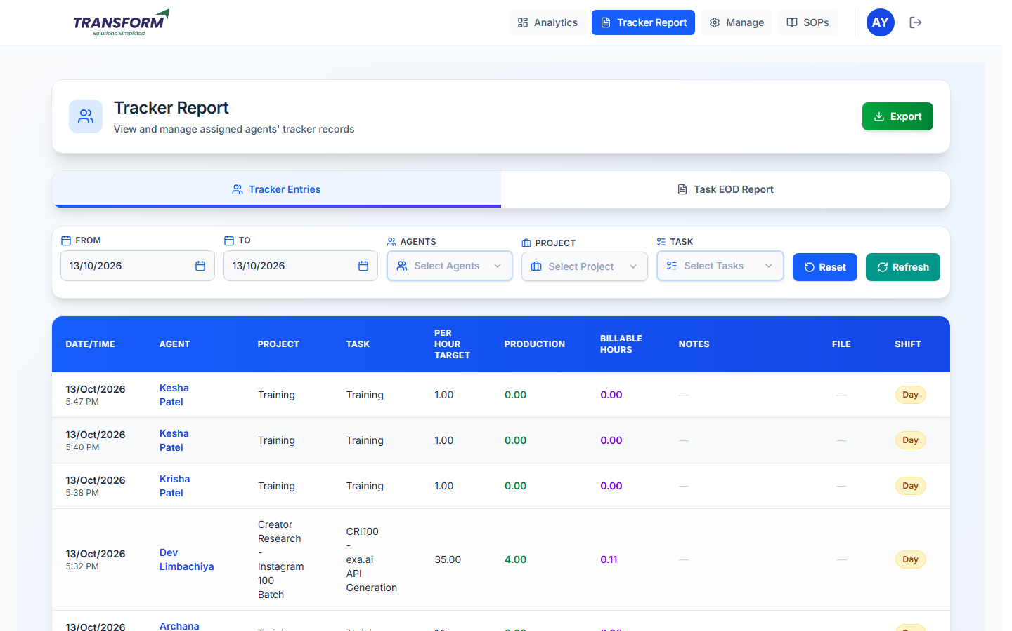
Figure 2: Tracker Report
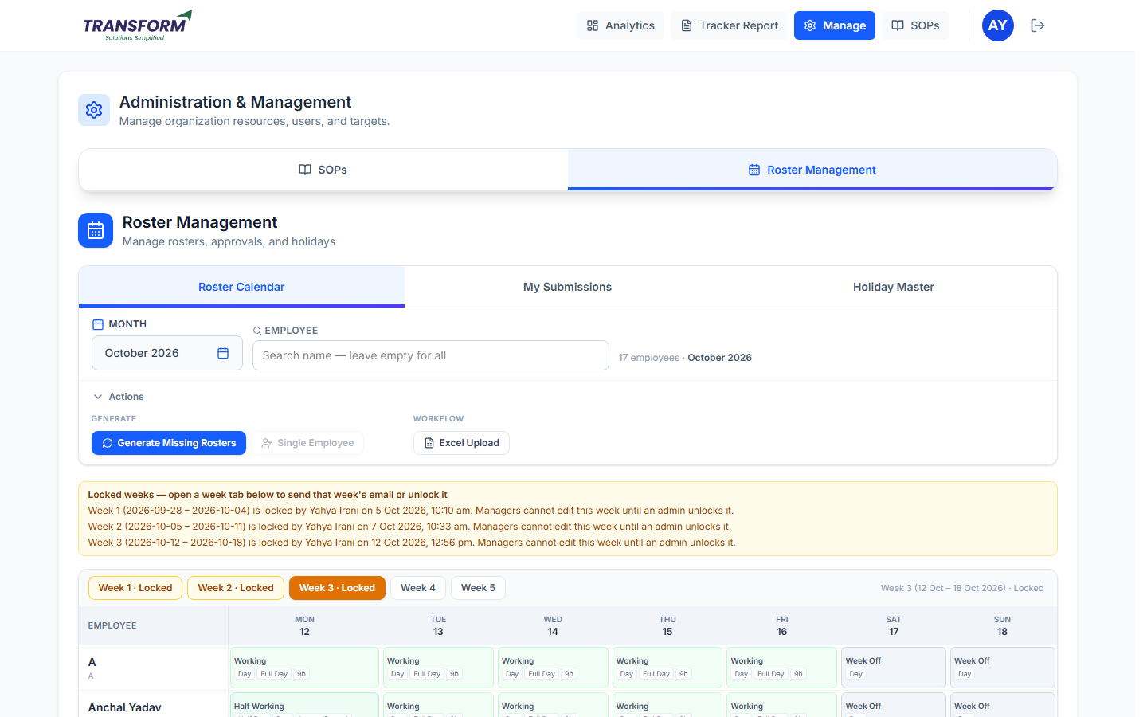
Figure 3: Roster Management (your team)

3. Rules
- You only see your own team (the Task EOD Report is the exception: it lists every project's tasks).
- You cannot change users, projects or tracker entries; ask your manager.
- Roster changes go to admin for approval and approved weeks lock.

